Welcome!
Date
Name
Spouse
Address
City
State Zip _________
Email

Please Contact By
❑ Card  Phone  Visit

Telephone Best Time to Call
Home ______________
Work ______________

Guest: First Time Second Time
Are you a church member: yes no
Church
City, State

Circle Appropriate Age/Grade Group(s)
Preschool: Ages: B-1 2-3 4-5
Children: Grades: K 1 2 3 4 5 6
Youth: Grades: 7 8 9 10 11 12
Adults: Ages:18-29 30s 40s 50s 60s+

How did you learn about our church?
Newspaper Friend Yellow Pages Mail
Other

I am a guest of:

New in the Community? Yes No
Names & ages of children at home

Weekly Service & Activity Schedule
January 19th, 2014
9:45 a.m. Sunday School
11 a.m. Morning Worship
Covered Dish Dinner

6 p.m. Evening Services
Business Meeting

Week of January 20 - 25

Wednesday, 6:30 p.m. Youth Activities
Wednesday, 6:45 p.m. Adult Prayer & Bible Study
Wednesday, 7:30 p.m. Praise Team Rehearsal
Thursday, 10:00 a.m. Adult Fellowship
Saturday My Hope America (Deacons)
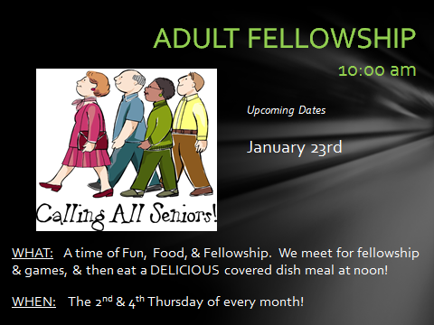

Upcoming Events

January
25 My Hope America (Deacons)
26 Baptist Men’s Day (Men’s Service)

Note: Beginning this month Birthday & Anniversary Recognitions will occur on the final Sunday Morning of each month.
Knobbs Springs Baptist Church

The earth is the Lord’s, and everything in it,
the world, and all who live in it; for he founded it
on the seas and established it on the waters.
Psalm 24:1-2

“Listen, my people, and I will speak; I will
testify against you, Israel: I am God, your God.
I bring no charges against you concerning
your sacrifices or concerning your burnt
offerings, which are ever before me.
I have no need of a bull from your stall or of
goats from your pens, for every animal of
the forest is mine, and the cattle on a
thousand hills. I know every bird in the
mountains, and the insects in the fields are
mine. If I were hungry I would not tell you,
for the world is mine, and all that is in it.
Do I eat the flesh of bulls or drink the blood
of goats? “Sacrifice thank offerings to God,
fulfill your vows to the Most High, and
call on me in the day of trouble;
I will deliver you, and you will honor me.”
Psalm 50:7-15

January 19, 2014

Church Information:
KnobbsSpringsBC.com KnobbsSpringsBaptist@gmail.com
1662 CR 305, McDade, Texas 78650 512-273-2743
Brother Dwight Reagan 512-247-6448
Kimberly Tabor, Office Manager 512-698-2804

